Karthik Pradeep Hegadi

**2KE20CS032**

**Assignment 1**

*Understood. To follow the provided instructions and create the files/directory using the same name and case as provided in the task steps, please provide me with the specific names and case instructions for the files/directory you want to create.*

**Assignment on User Management and Permissions**

**Task 1: Login as root create User and Provide sudo privilege**

1)To create a new user for this assignment and set a password for the new user

2)now provide sudo privileges to the user you created

Just we need ***visudo*** command to be run ***and change the configure file <lusi > ALL=(ALL) ALL***

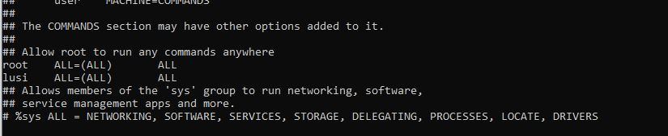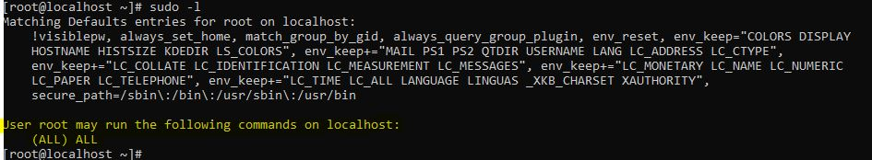

3)To log out of the root user and log in as the new user.

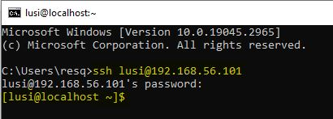

**Task 2 :Managing users**

1)Create users "webuser", "appuser", and "dbuser":

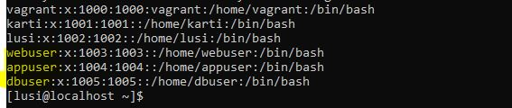

2)Create groups "web", "app", and "db":

create



check



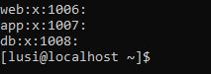

3)Add "webuser" to the "web" group, "appuser" to the "app"

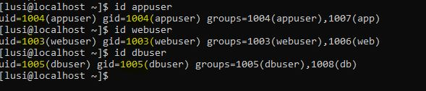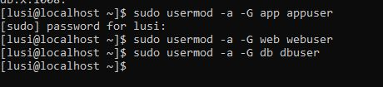

4) Set“sh”as the default shell for“webuser”,“appuser”,“dbuser”

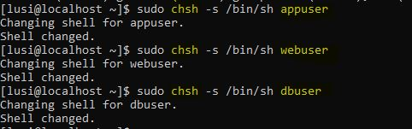

5.Set /tmp as default home directory for all the users

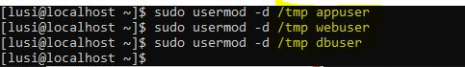

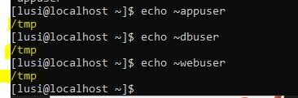

**Task 3 : Providing permissions**

1)Create the directory structure for the app as /web/bin:

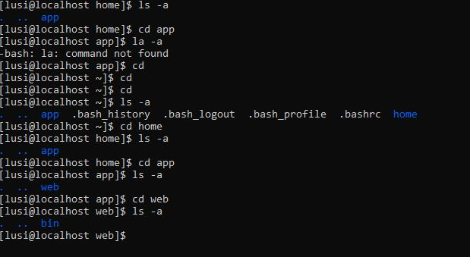

2)Change the ownership of the web directory to webuser and change the group to webgroup:



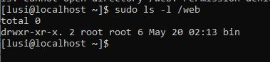

3)Provide "rwx" permissions for webuser, "rw" permissions for webgroup, and "r" permissions for others to the /web directory

